## 

Our Group Members:

**Submitted To:**

[eprojects@aptech.ac.in](mailto:eprojects@aptech.ac.in)

**Project Instructor:**

**SIR MUHAMMAD HASHIR**

## Jazil Ahmed:

## (Student1488951)

## MuhammadHammad Ali:

## (Student1499468)

## Moiz:

## (Student1488911)

v

## TABLE OF CONTENT

**Project certification……………………………………………………….……….4**

**Introduction of ROCK PARADISE…………….……………………………………5**

**Requirement specification………………………………………..………...6**

**Home page……………………………………………………………….………………....10**

**About us…………………………………………………………………………………………11**

**Merchandise…………………………………………………..………………………..….12**

**Contact us……………………….……………………………………..….………………...13**



**We are thankful to Almighty, ALLAH that by His grace we have been successful. We also thanks to “SIR MUHAMMAD HASHIR”**

**we presenting on Visual Studio Code in your hands.**

**This is our First Year Semester E-project. We have tried our best & struggled for a better outlook to come. This project has been developed in Visual Studio Code. We choose to make Webpage for Rock paradise as a project. We find easy to do coding in Visual Studio Code.**

**We earnestly hope that this project will provide all the necessarily information required for the user to fulfill their inspiration. However, suggestions for improvement of the project will be thankful received & acknowledge**

**ACKNOWLEDGEMENT**



**PROJECT CERTIFICATION**

***Jazil Ahmed (Enrolment # student 1488951), Muhammad Hammad Ali(Enrolment # student 1499468) & Moiz (Enrolment # student 1488911) has successfully designed and developed:***

**Rock Paradise**

***Submitted by***

***Aptech computer Education***

***Date of issue:***

**15-dec-2023**

***Date of submission:***

**05-jan-2024**

**INTRODUCTION OF ROCK PARADISE**

**We are a group of 3 student. We watch all sorts of Rock Paradise in all sorts of countries, then write reports and feature articles about them which are published in a newspaper. This is a fine and privileged occupation, and one to be disclosed with tact. People who do respectable, important jobs don’t like to hear about it.**

**1) The Home Page should be created making use of Frames.**

**2) A Menu should be created which would categorize all the information about the features provided in the Site For e.g. a Menu for Various Brands, a Menu for Features of Rock-Paradise etc something like that.**

**3) The Shop display should be categorized according to the Brand names of Rock-paradise like if a User wants to see only PENDORA Jewelery then he click on Some PENDORA Link/button etc and he will see only That Brand Rock-Paradise and so on.**

**4) A Products of features of Individual Rock-Paradise should be displayed on the Web Page along with the AC but detailed Features should be stored in Individual Word documents which can be downloaded or viewed by the User who wishes to see the same.**

**5) A Brands Web Page should also be there where there is Air-conditioner comparisons done with various models of same brand or various models of various brands.**

**- The Brands information should be provided in Tabular format comparing the features of different** Brands

**- This Brands would be for 5 Air-conditioner of similar brands and 2 C of different brands for 1 month and then it will change so for the time being the Page should handle the above requirement.**

**6) There should be a “Contact Us” page which will have the Address of the Company which is as follows and the mail address which when clicked will invoke the local mail client from where they can send an email**.

**HARDWARE & SOFTWARE/REQUIRMENT**

**Hardware:**

* Intel Core i3/i5 Processor or higher
* 8 GB RAM or above
* Color SVGA
* 500 GB Hard Disk space
* Mouse
* Keyboard

**Software:**

Technologies to be used:

* Frontend: HTML5, CSS, Bootstrap, JavaScript, jQuery, AngularJS, XML
* Data Store: JSON files or TXT files

Other Requirements:

* Operating Portal: Windows
* Browsers: Edge, Chrome, Mozilla Firefox, Safari

**PROJECT DURATION**

1. Analysis-18 Hrs.
2. Design – 22 Hrs.
3. Development –20Hrs
4. Testing – 12 Hrs
5. Documentation -11 hrs

TASK SHEET

|  |  |  |  |  |
| --- | --- | --- | --- | --- |
| NO. | Task | Start | Finish | Resource Names |
| 1. | **Analysis** | **01-jan-24** | **03-jan-24** | **Jazil Ahmed** |
| 2. | **Solution Design** | **17-dec-23** | **01-Jan-24** | **Jazil Ahmed, Muhammad Hammad Ali, Moiz** |
| 3. | **Development** | **16-Dec-23** | **01-jan-24** | **Jazil Ahmed, Muhammad Hammad Ali, Moiz** |
| 4. | **Documentation** | **30-Dec-23** | **01-Jan-24** | **Muhammad Hammad Ali, Moiz** |

**LIST OF VALIDATION**

|  |  |
| --- | --- |
| Option | Validation |
| Fields in Form should not be Null | **Yes** |
| Hyperlinks Have Alternating Text | **No** |
| Search Pages | **No** |
| Homepage Has Forward Only Link | **yes** |
| All Web pages have link back to Homepage | **Yes** |
| Request Quote Form Included | **No** |
| All Functions Are Compatible with Firefox | **Yes** |
| All Functions Are Compatible with IE | **Yes** |

**SUBMISSION CHECK LIST**

|  |  |  |  |
| --- | --- | --- | --- |
| No. | List of Items | Remarks | Comments |
| 1) | **Do All Pages Linked together** | **Yes** |  |
| 2) | **Are structure (HTML), presentation (CSS), and behavior (JavaScript) separated** | **Yes** |  |
| 3) | **Are the links visible** | **Yes** |  |
| 4) | **Site Browser Compatible** | **Yes** | **Tested in Chrome, Microsoft Edge.** |
| 5) | **Feedback Form Included** | **No** |  |
| 6) | **Project Zip File** | **Yes** | **Created using WinRAR** |

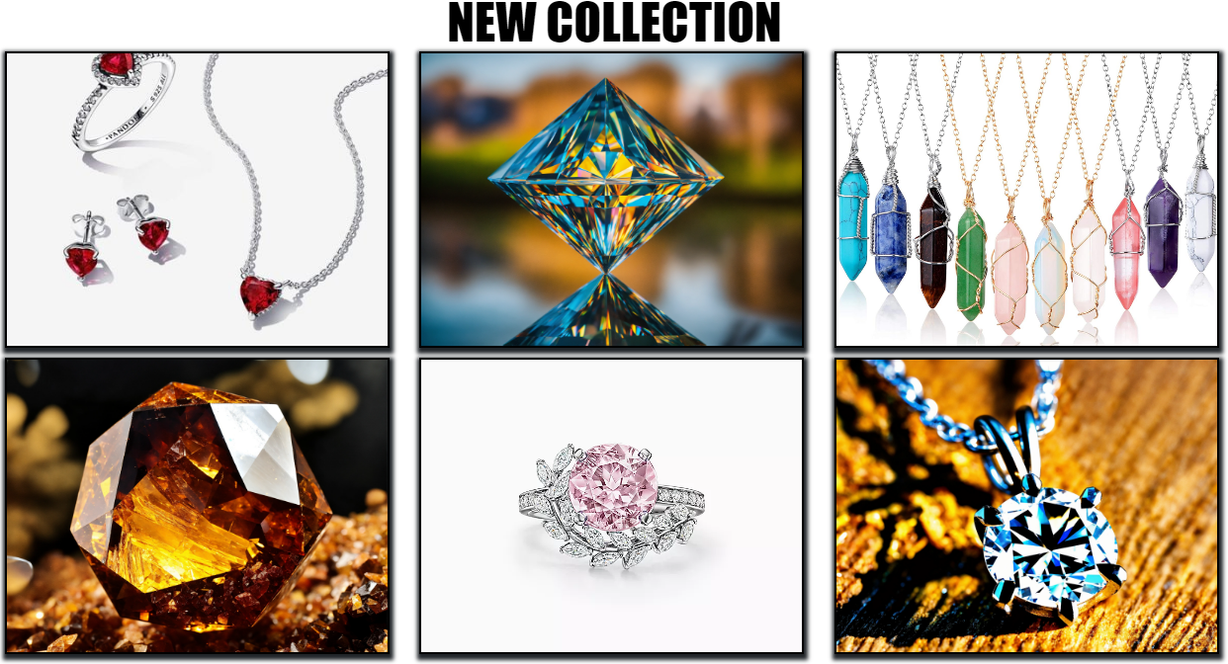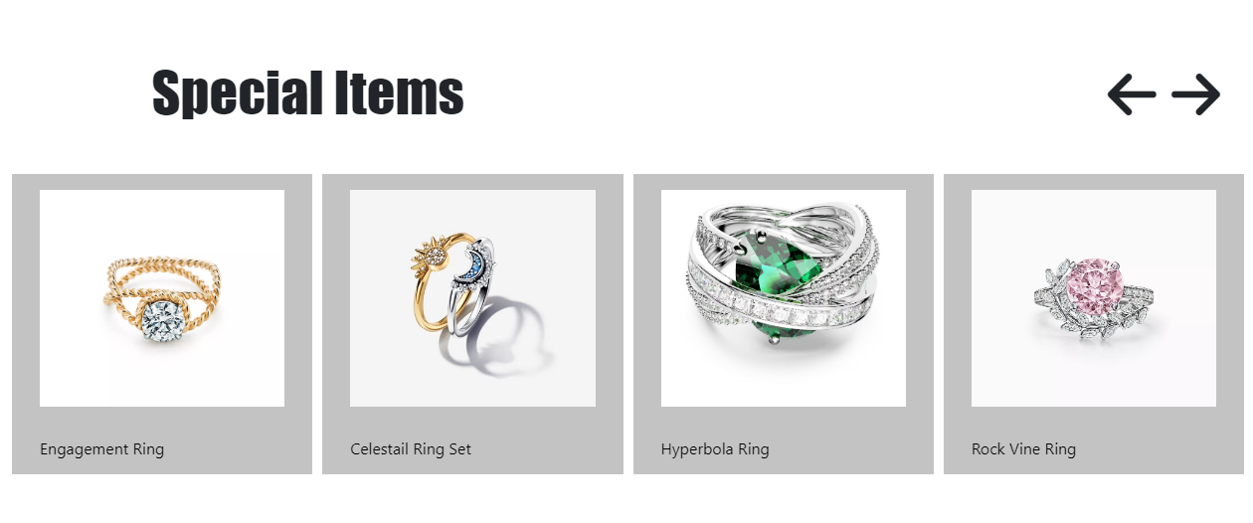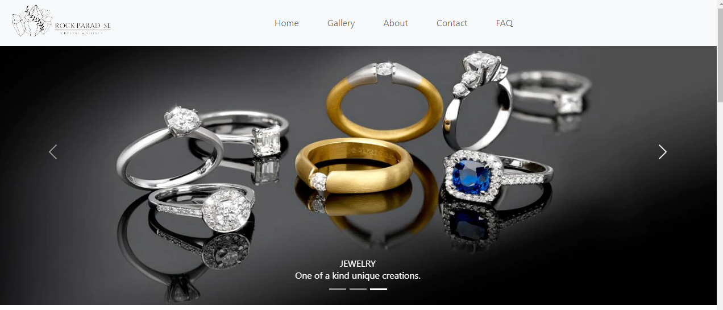**HOME PAGE**

**ABOUT US PAGE**

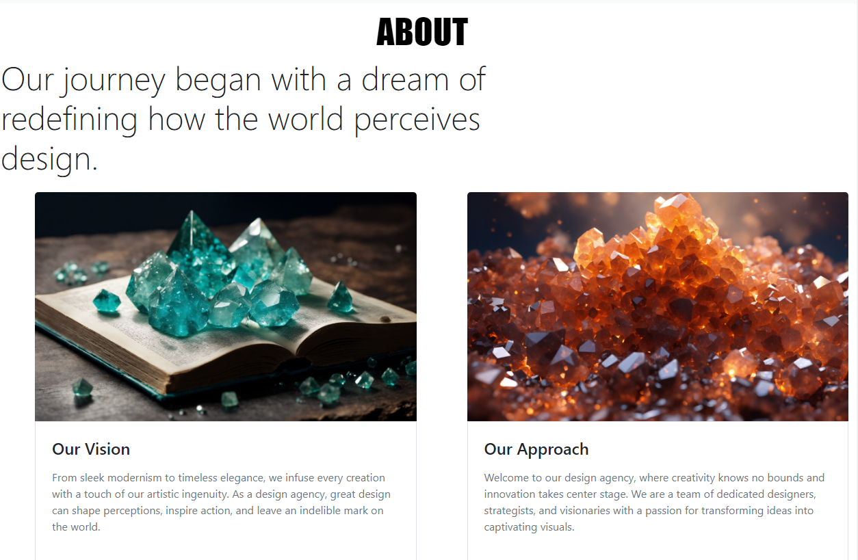

**CONTACT US PAGE**

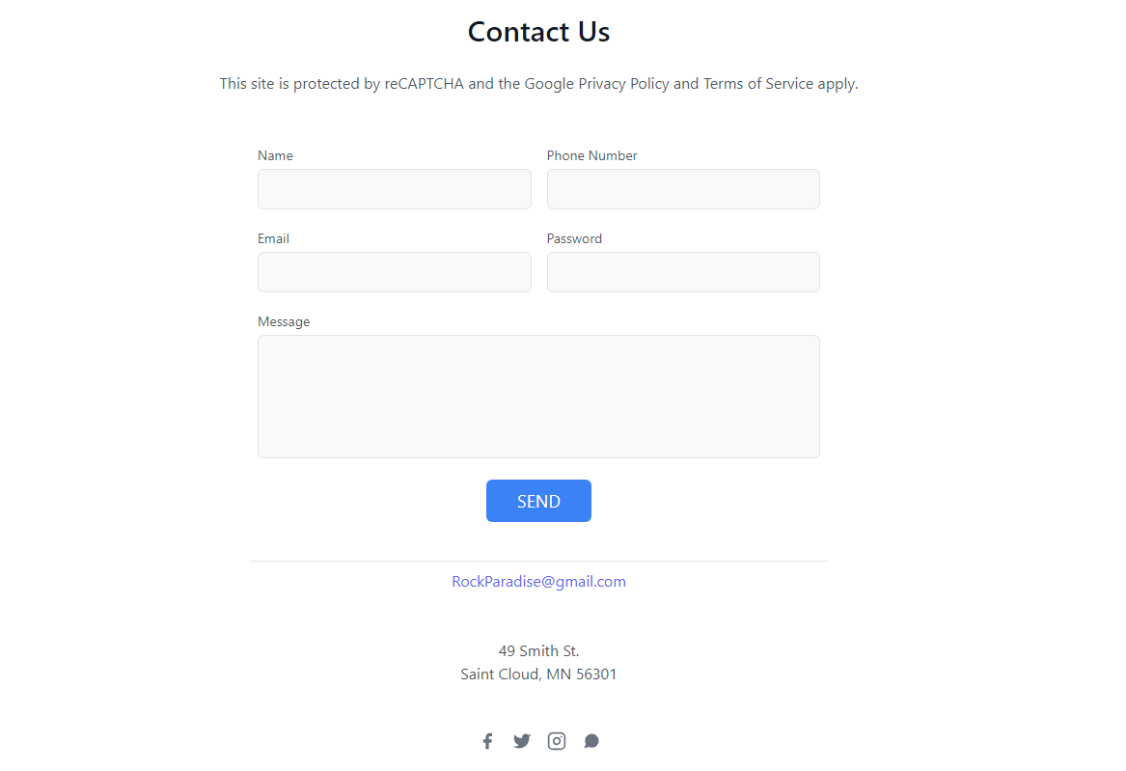

**THANK YOU**

**……….YOUR REGARDS……….**

**“IF YOU ANY QUERIES PLEASE CHECK OUR WEBSITES”**